[Village of Dryden DPW Building Energy Use – Acct 281](Village%20of%20Dryden%20Municipal%20Building%20Energy%20Usage.docx)

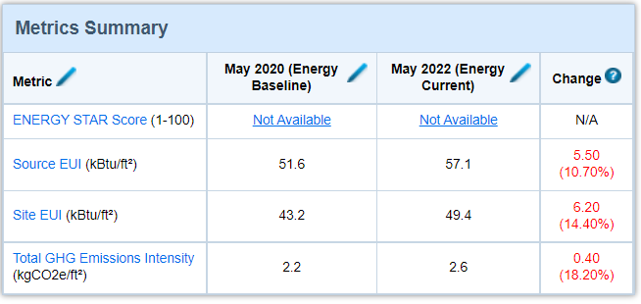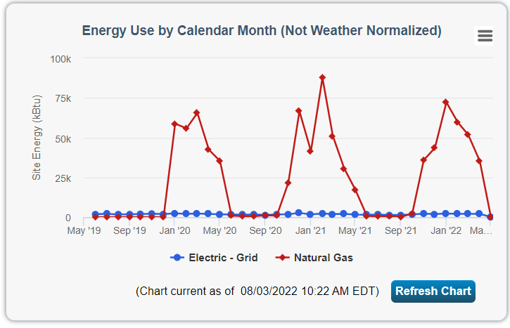

Village of Dryden DPW Old Garage Energy Use – Acct 273

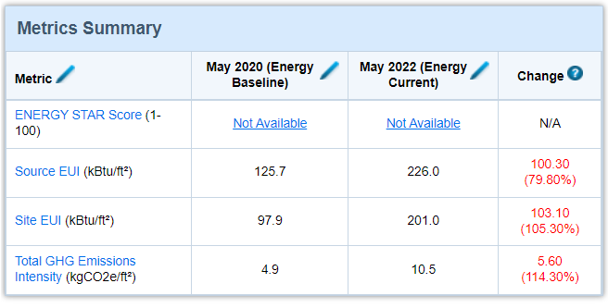

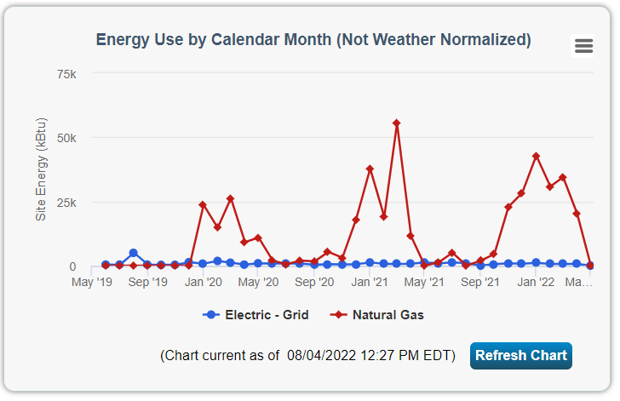

Village of Dryden Pebble Drive STP Energy Use – Acct 178 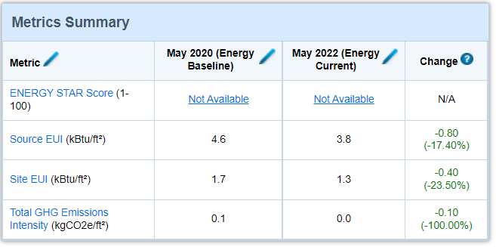

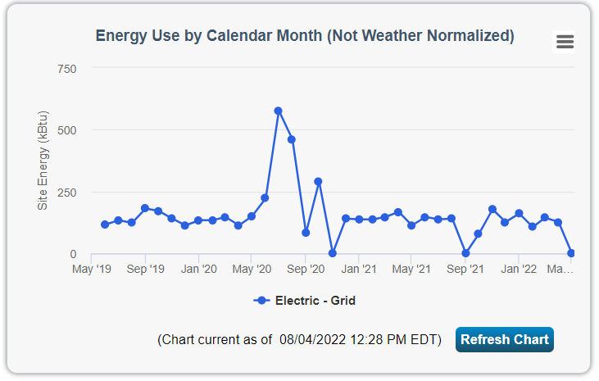

Village of Dryden Phase 3 STP Energy Use – Acct 569

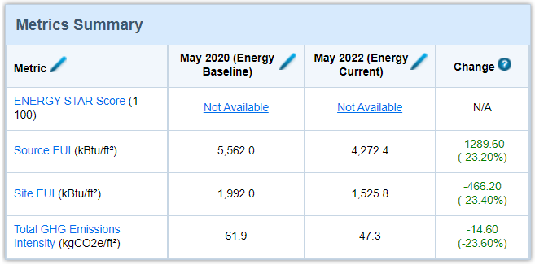

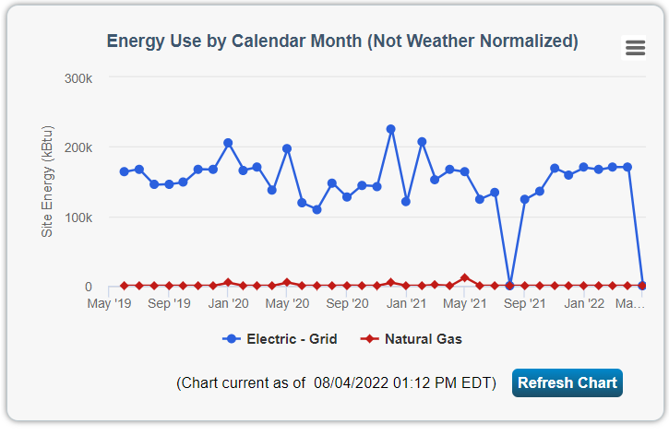

Village of Dryden Phase STP Energy Use – Acct 616

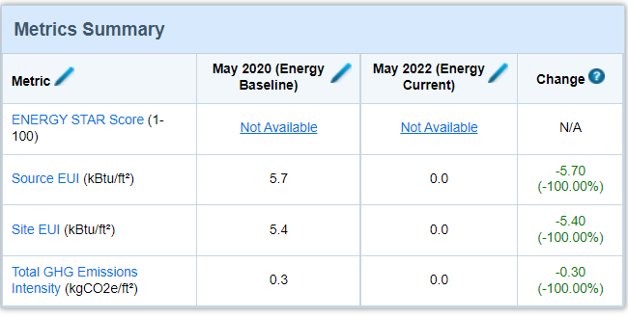

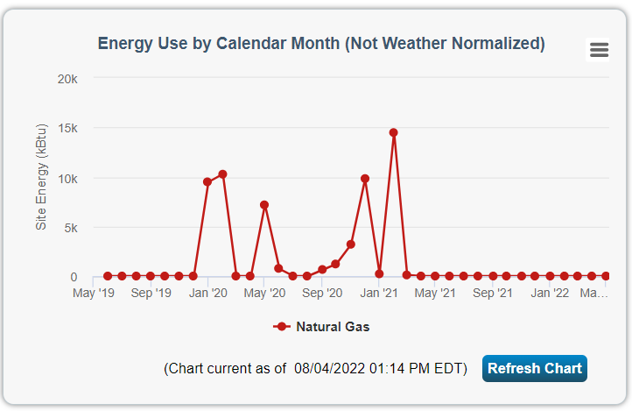

Village of Dryden Village Hall Energy Use – Acct 911

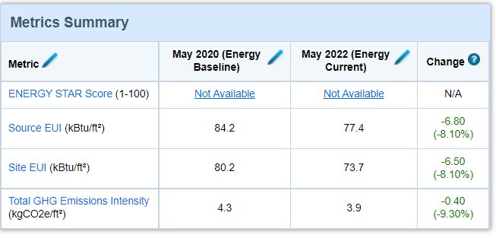

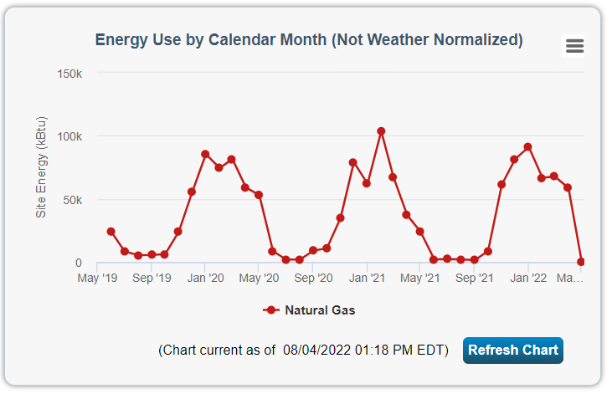

Village of Dryden Village Hall Energy Use – Acct 929

